EXPERIMENT: 1 Develop and design web application to change background color and menus.

[31/07/2024]

AIM:

To develop and design the mobile or web application to change the background colors and menu.

PROCEDURE:

1.Find the suitable mobile or web application to replicate its elements and design.

2.Create the frame in required width and height.

3.Create the Basic elements and adjust its borders as per the dimensions.

4.Align the text in suitable format and size, that should be in professional way.

5.Add the background colors based on the color theory.

6.Use the plugins to symbolical representation and export the output in required formats like PNG,JPEG,PSD,TIFF,etc.,

OUTPUT: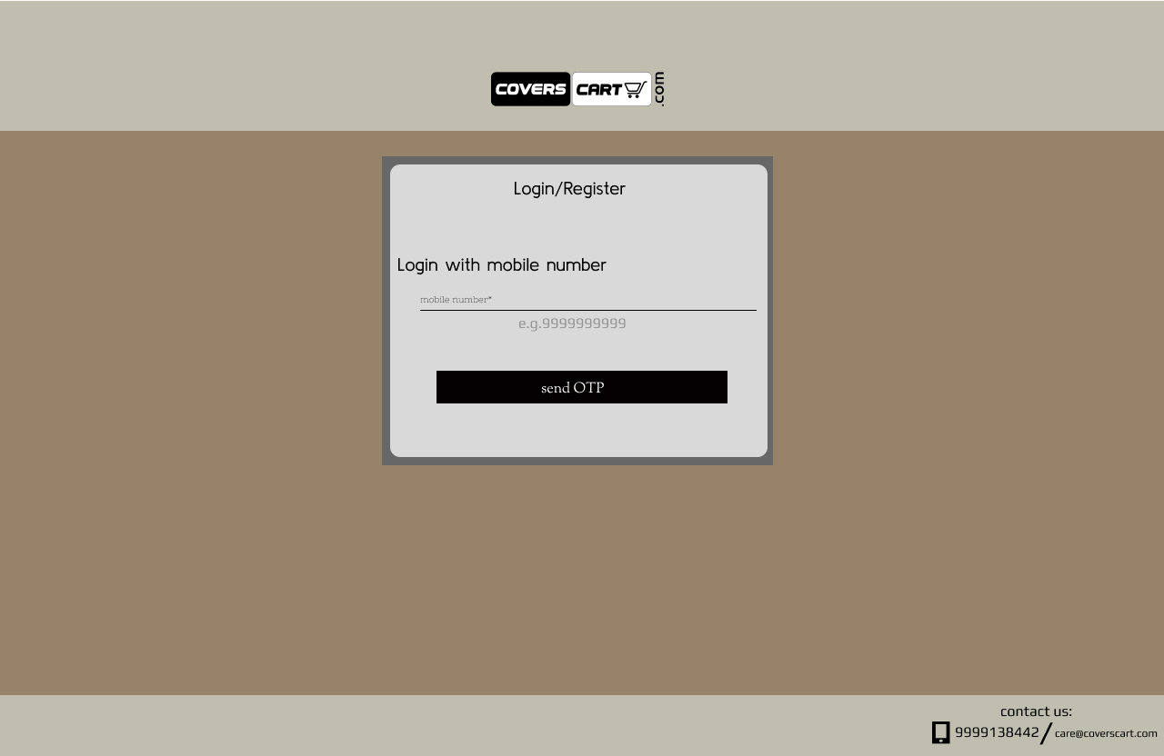

RESULT:

The web application is created and the background color is changed successfully.